How to Access your
Temple MySql Database
using MySqlWorkbench

1. Find Your MySQL Credentials for Your Database (on cis-linux2) 2
2. Create a Connection to MySQL and Test It 3
3. Connect to MySql on cis-linux2 5
4. Select Your Database as the Default Database 6

Find Your MySQL Credentials for Your Database (on cis-linux2)
The CIS department’s “Database Administrator” has created a MySql database for you on cis-linux2, assigned you access, and provided a username and password for you. Your database credentials (database name, username/password, etc) have been saved in a text file on your (private) home folder on cis-linux2. To find your credentials to your production database, use Secure Shell (or other program) to telnet or ftp into cis-linux2.temple.edu. Secure Shell is available in the CIS Department Labs and you can install it at home if you like. It is available for free download from here: https://download.temple.edu/ If you have a mac, you should be able to telnet directly from a terminal window or you can download Cyberduck from the internet.
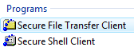
Log in with your AccessNet username (e.g., tua12345) and (regular tumail) password.
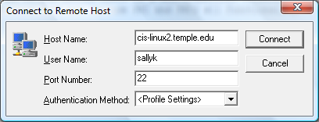
Once in, look in your home folder for a file named MySQL.txt. Your home folder is the directory where you should find yourself when you first log into cis-linux2. It should be here: /home/TU/tua12345
Inside the MySQL.txt file you will find your MySQL username (same as your temple username), your MySql password (randomly generated), and a database name (semester/year abbreviation, underscore, course number, underscore, then your Temple username).
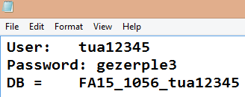
Take note of your database name, username/password (& store this information to a place that you can easily find later), then close out of the file and then close out of Secure Shell.

Create a Connection to MySQL and Test It
To create a connection that connects to the MySQL daemon on cis-linux2 at Temple, click on the plus sign after “Connections”. Or you can select “Database” – “Manage Connections” – “New”.
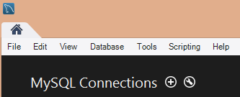
Create a connection as shown below. Note: many of the textboxes do not appear until you select “TCP over SSH”.
- Enter a connection name. I chose “linux2”, but you can choose what you like.
- For Connection Method, select “Standard TCP/IP over SSH” since our server only accepts secure connections.
- For SSH Hostname, enter the name of our server: cis-linux2.temple.edu
  - For SSH Username, enter your Temple/TuMail username (e.g., tua12345).
  - For SSH Password, click the “Store in Vault” button and enter your Temple/TuMail password. This logs you into cis-linux2, the server’s operating system.
- For MySQL Hostname, enter the same server: cis-linux2.temple.edu
  - For MySQL Username, enter your MySQL username (which was created to match your Temple username).
  - For MySQL Password, click “Store in Vault” and enter the auto-generated DB password you just discovered. This logs you into the MySQL DBMS software that is running on cis-linux2.
- Leave everything else as is. If you are SURE you typed in your passwords correctly, click “Test Connection”.
- Remember if you try to log into any temple system more than 3 times incorrectly, you will be locked out for 30 minutes. Your only option is to wait and try again.

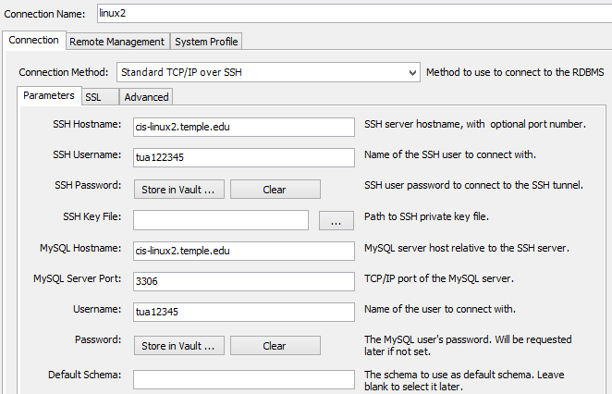
- If all went well, you should see this screen a message indicating that the connection parameters are correct.
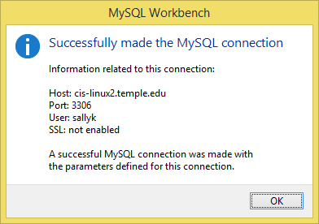
- If you get connection error messages, press both “Clear” buttons (next to the “Store in Vault” buttons) and re-enter your passwords again, being more careful this time (if ssh is asking, enter your Temple/TuMail password, if MySql is asking, enter your auto-generated DB password). If you fail to log in within 3 tries, your Temple account will be locked out and your only option is to wait 30 minutes then try again. After the 30 minutes, you might want to log into TuPortal first, just to be sure you have your Temple/TuMail password correct.
When you close the connection window, your connection should be saved for future use and you’ll see it on the MySqlWorkbench splash screen:
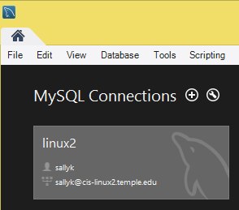

Connect to MySql on cis-linux2
If you created a connection (from the previous step), then you should be able to see your connection (whatever you named it), from the main MySqlWorkbench splash screen:
Double click on the connection and (if you saved your two passwords in the vault), you should see all the database schemas that have been created on cis-linux2). Otherwise, you have to enter your password(s). Remember to pay close attention to which service is asking you for your password. If it is the ssh service asking you for your password, enter your Temple/TUMail password (to log into the operating system on cis-linux2):
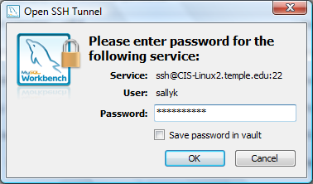
If it is the Mysql service asking you for your password, enter your MySQL password (the auto-generated one you just found from the MySQL.txt file).
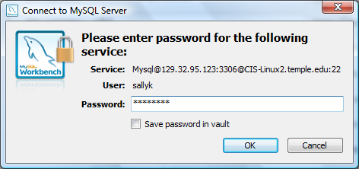

Select Your Database as the Default Database
Once you connect to the MySql Database Management System software, you should see a screen like this (with a LOT of student database listed in the database schema list). The first thing you should do is select your database as the default database. If you select your database schema as the default, it will be easier for you to enter your SQL commands because you will not have to prefix each table name with the database name, i.e., you will be able to type:
select * from customer;

instead of having to type:
select * from SP14_2308_tua12345.customer;
Specify your database as the default database by double clicking on your database name.
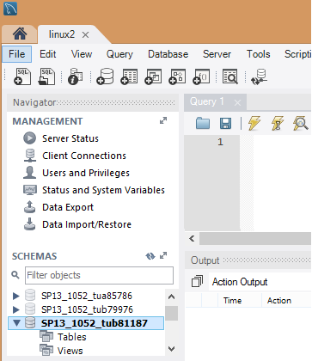
Double click your database to make it the default (database name will show in bold).

If you forget to set your database as the default database, you’ll see an error message (in the Output pane) when you try to run a query:
Error Code: 1046. No database selected. Select the default DB to be used by double-clicking its name in the SCHEMAS list in the sidebar.
Or you may see an error message that says you are not authorized to access someone else’s database.

Once you have set your database as default, you are ready to start working with your database, creating tables, entering data, running SQL select statements.

